Christian Edition
A Men’s Chorus

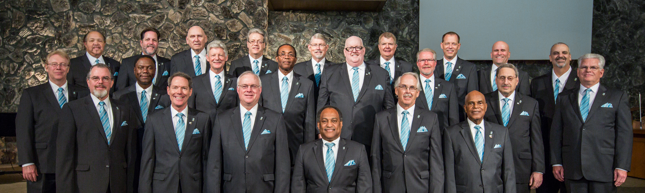

In Concert
Saturday, April 21, 2018

at 11:00 a.m.

Colton SDA Church

This internationally known and acclaimed men’s chorus will join us in worship as they present a program of classic Christian hymns and selected contemporary sacred music. Bring your friends to this outstanding event.

Christian Edition
A Men’s Chorus

In Concert
Saturday, April 21, 2018

at 11:00 a.m.

Colton SDA Church

This internationally known and acclaimed men’s chorus will join us in worship as they present a program of classic Christian hymns and selected contemporary sacred music. Bring your friends to this outstanding event.

